25.10 Editors - Properties Editor - Physics Tab
Physics 1
Gravity 1
Collisions 2
Options 2
Soft Body and Cloth Interaction 3
Force Field Interaction 3
Examples 4
Hints 4

Physics

The Physics chapter covers various advanced Bforartists effects, often used to simulate real physical phenomena, such as:
- Smoke
- Rain
- Dust
- Cloth
- Water
- Jello
Particle Systems can be used to simulate many things: hair, grass, smoke, flocks.
Hair is a subset of the particle system, and can be used for strand-like objects, such as hair, fur, grass, quills, etc.
Soft Bodies are useful for everything that tends to bend, deform, in reaction to forces like gravity or wind, or when colliding with other objects... It can be used for skin, rubber, and even clothes, even though there is separate Cloth Simulation specific for cloth-like objects.
Rigid Bodies can simulate dynamic objects that are fairly rigid.
Fluids, which include liquids and gases, can be simulated, including Smoke.
Force Fields can modify the behavior of simulations.

Gravity
Gravity is a global setting that is applied the same to all physics systems in a scene, which can be found in the scene tab. This value is generally fine left at its default value, at -9.810 in the Z axis, which is the force of gravity in the real world. Lowering this value would simulate a lower or higher force of gravity. Gravity denoted g, measurement [m×s -2]).
Gravity is practically same around whole Earth. For rendering scenes from Moon use value 6 times smaller, e.g. 1.622 m×s -2. The most popular and probably not colonized Mars has g = 3.69.
Note that you can scale down the gravity value per physics system in the Field Weights tab.

Collisions

Particles, Soft Bodies and Cloth objects may collide with mesh objects. Boids try to avoid Collision objects.
- The objects need to share at least one common layer to have effect.
- You may limit the effect on particles to a group of objects (in the Field Weights panel).
- Deflection for softbody objects is difficult, they often penetrate the colliding objects.
- Hair particles ignore deflecting objects (but you can animate them as softbodies which take deflection into account).
If you change the deflection settings for an object you have to recalculate the particle, softbody or cloth system (Free Cache), this is not done automatically. You can clear the cache for all selected objects with Ctrl-B –> Free cache selected.
Reference
Mode: Object Mode
Panel: Object context –> Physics sub-context –> Collision

Options
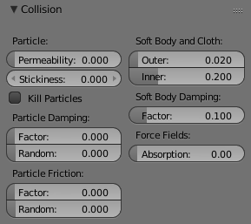
Collision Panel
Permeability
Fraction of particles passing through the mesh.
Stickiness
How much particles stick to the object.
Kill Particles
Deletes Particles upon impact.
Damping Factor
Damping during a collision (independent of the velocity of the particles).
Random damping
Random variation of damping.
Friction Factor
Friction during movements along the surface.
Random friction
Random variation of friction.
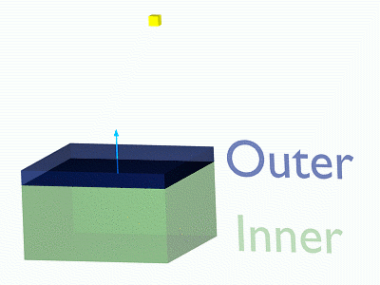
Image 1b: A softbody vertex colliding with a plane.

Soft Body and Cloth Interaction
Outer
Size of the outer collision zone.
Inner
Size of the inner collision zone (padding distance).
Outside and inside is defined by the face normal, depicted as blue arrow in (Image 1b).
Damping Factor
Damping during a collision.
Softbody collisions are difficult to get perfect. If one of the objects move too fast, the soft body will penetrate the mesh. See also the section about Soft Bodies.

Force Field Interaction
Absorption
A deflector can also deflect effectors. You can specify some collision/deflector objects which deflect a specific portion of the effector force using the Absorption value. 100% absorption results in no force getting through the collision/deflector object at all. If you have 3 collision object behind each other with e.g. 10%, 43% and 3%, the absorption ends up at around 50% (100×(1-0.1)×(1-0.43)×(1-0.03)).

Examples
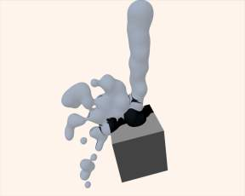
Deflected Particles
Here is a Meta object, dupliverted to a particle system emitting downwards, and deflected by a mesh cube:

Hints
- Make sure that the normals of the mesh surface are facing towards the particles/points for correct deflection.
- Hair particles react directly to force fields, so if you use a force field with a short range you don’t need necessarily collision.
- Hair particles avoid their emitting mesh if you edit them in Particle mode. So you can at least model the hair with collision.

